JOIN US FOR
COFFEE WITH THE CITY MANAGER!
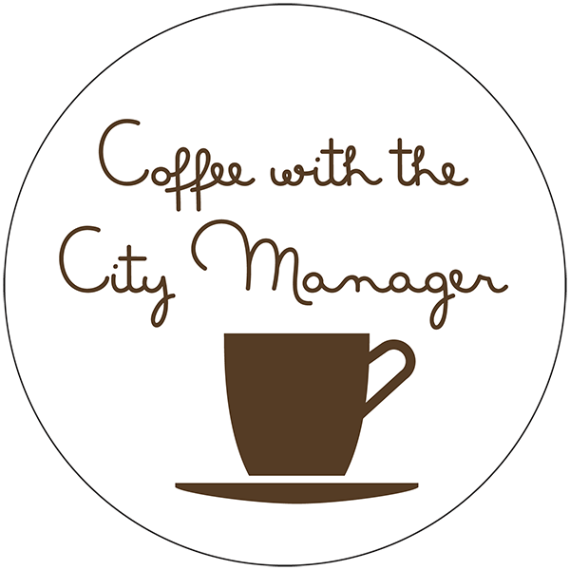


Are you looking for a better way to get answers to your local government questions or express your ideas and concerns for your City? Then save the date and join us at this sit-down event, offered in a relaxed atmosphere, face-to-face with the City Manager.
Castle Hills City Manager Ryan Rapelye will be hosting informal gatherings to interact with community members, gather feedback on City programs and services, and to answer questions. In addition to topics brought up by residents; Mr. Rapelye will provide an update on projects and other initiatives underway with the aim to inform and promote city services.
The purpose is to provide accurate and substantive information to residents and utilize this platform for citizen engagement and transparency. Currently, the City provides information via its website and social media outlets, but unfortunately not everyone has the ability to access this information. This is a proactive approach in the dissemination of information by meeting with citizens one-on-one to hear ideas and voice concerns. The City Manager will be joined at these coffees along with city staff.
The sessions are open to the public and are an unstructured, drop-in format. Bring your comments/questions and come enjoy the coffee!
FRIDAY,
MAY 10 TH
9:00 A.M. – 10:00 A.M.

COMMUNITY ROOM
CITY HALL
209 LEMONWOOD DR.

